**Name: Atharva Salitri Division: CSAI B Batch: 2**

**Roll No.: 37 PRN: 12310120**

**Subject: OS Lab Assignment 1**

**Title: Linux Commands**

1. Change your password to a password you would like to use for the remainder of the semester.

**Command:** passwd

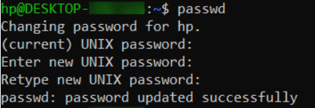

2. Display the system’s date.

**Command:** date



3. Count the number of lines in the /etc/passwd file.

**Command:** wc -l /etc/passwd

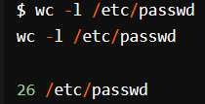

4. Find out who else is on the system.

Command: who or w

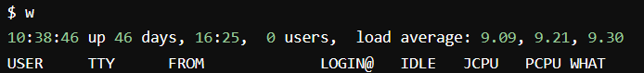

5. Direct the output of the man pages for the date command to a file named mydate.

**Command:** man date > mydate

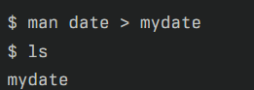

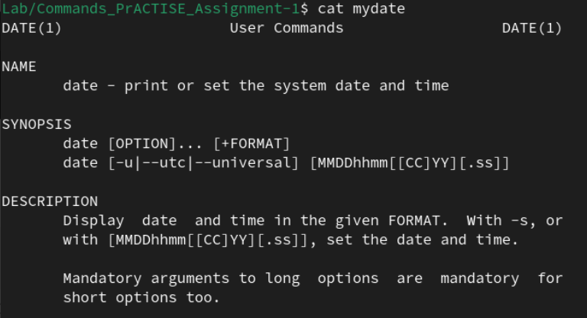

6. Create a subdirectory called mydir.

**Command:** mkdir mydir





7. Move the file mydate into the new subdirectory.

**Command:** mv mydate mydir/

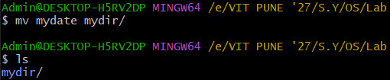

8. Go to the subdirectory mydir and copy the file mydate to a new file called ourdate

**Command:** cp mydate ourdate

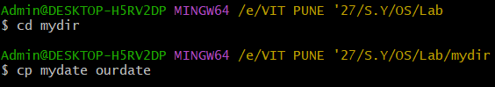

9. List the contents of mydir.

**Command:** ls



10. Do a long listing on the file ourdate and note the permissions.

**Command:** ls -l ourdate

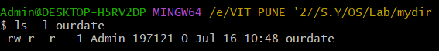

11. Display the name of the current directory starting from the root.

**Command:** pwd



12. Move the files in the directory mydir back to your home directory.

**Command:** mv mydir /*

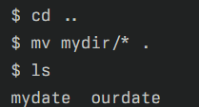



13. Display the first 5 lines of mydate.

**Command:** head -5 mydate





14. Display the last 8 lines of mydate.

**Command:** tail -8 mydate



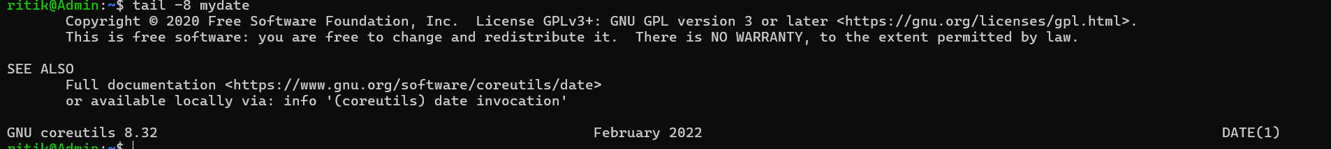

15. Remove the directory mydir.

**Command:** rm -r mydir or rmdir mydir

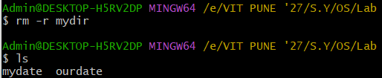

16. Redirect the output of the long listing of files to a file named list.

**Command:** ls -l > list

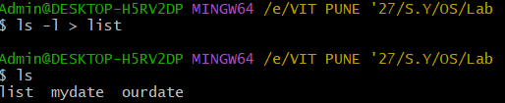

17. Select any 5 capitals of states in India and enter them in a file named capitals1. Choose 5 more capitals and enter them in a file named capitals2. Choose 5 more capitals and enter them in a file named capitals3. Concatenate all 3 files and redirect the output to a file named capitals.

**Command :** cat capitals1 capitals 2 capitals3 > capitals

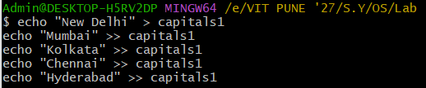

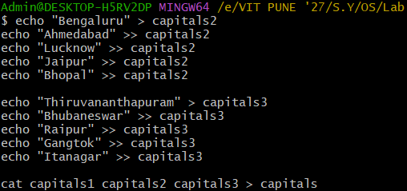

18. Concatenate the file capitals2 at the end of file capitals.

**Command:** cat capitals capitals2 >> capitals

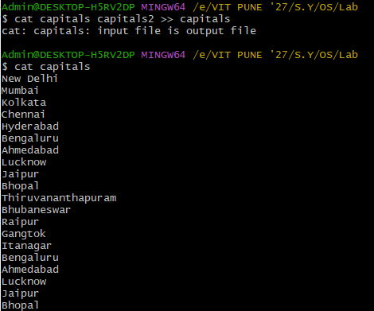

19. Give read and write permissions to all users for the file capitals.

**Command:** chmod 666 capitals

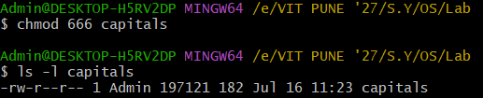

20. Give read permissions only to the owner of the file capitals. Open the file, make some

changes and try to save it. What happens ?

**Command:** chmod 400 capitals

The file will remain unchanged.

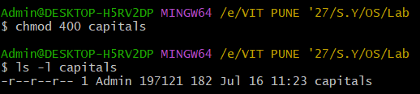

21. Create an alias to concatenate the 3 files capitals1, capitals2, capitals3 and redirect the output to a file named capitals. Activate the alias and make it run.

**Command:** alias concat='cat capitals1 capitals2 capitals3 > capitals'





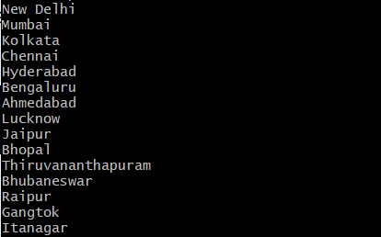

22. Find out the number of times the string “the” appears in the file mydate.

**Command:** grep -o -i "the" mydate | wc -l



23. Find out the line numbers on which the string “date” exists in mydate.

**Command:** grep -n "date" mydate

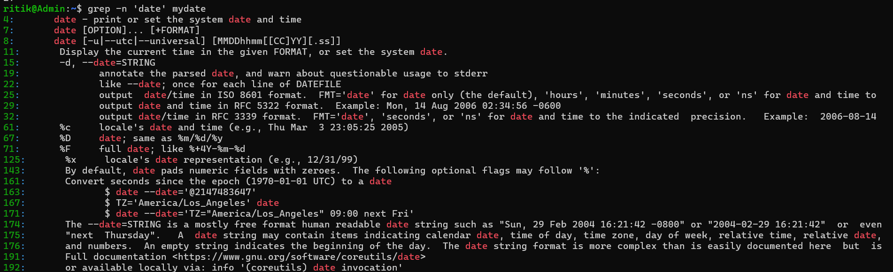

24. Print all lines of mydate except those that have the letter “i” in them.

**Command:** grep -v ‘i’ mydate

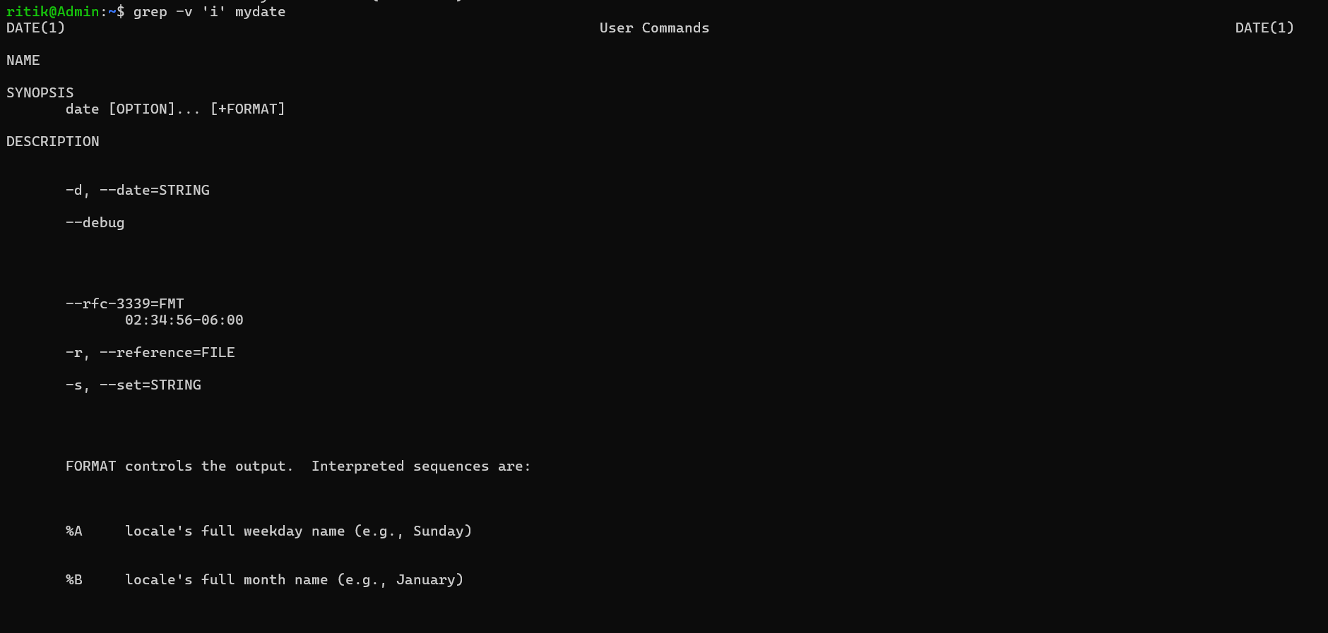

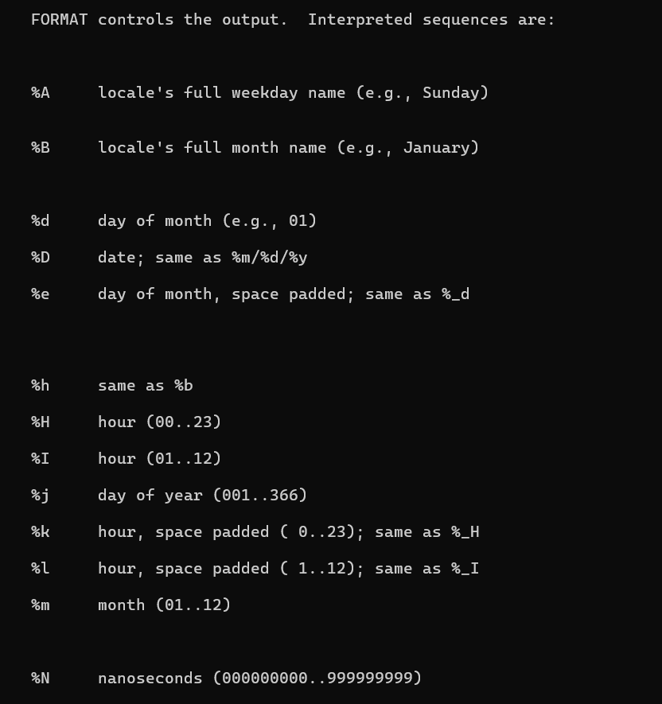



25. List the words of 4 letters from the file mydate.

**Command:** grep -o ‘\b\w\{4\}\b’ mydate

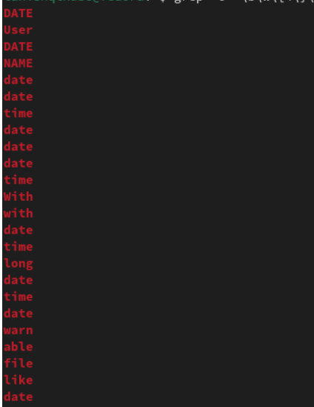

26. List 5 states in north east India in a file mystates. List their corresponding capitals in a file mycapitals. Use the paste command to join the 2 files.

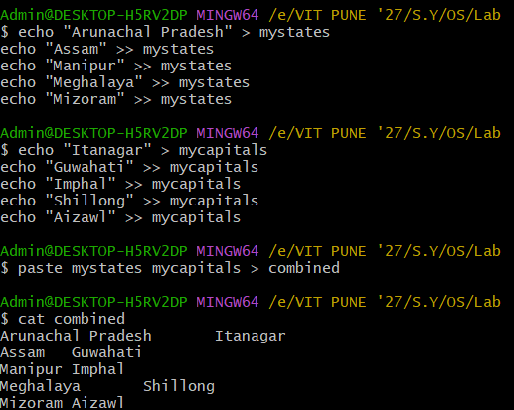

27. Use the cut command to print the 1 st and 3 rd columns of the /etc/passwd file for all students in this class.

**Command:** cut -d: -fl,3 /etc/passwd

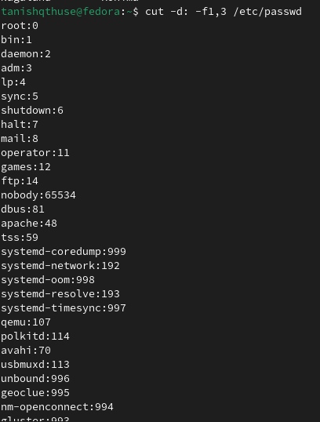

28. Count the number of people logged in and also trap the users in a file using the tee command.

**Command:** who | tee users.txt | wc -1



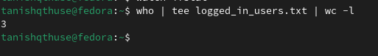

29. Convert the contents of mystates into uppercase.

**Command:** tr '[:lower:]' '[:upper:]' < mystates > mystates_upper



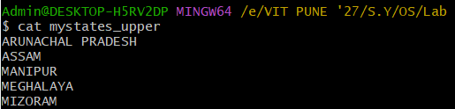

30. Create any two files & display the common values between them.

